The Schools Report for Health Creation at School (HCAS)

A Dynamic new Programme for Proactive Health and Wellbeing for Teachers

Background and Leadership

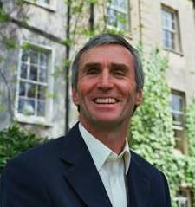
Health Creation at School was started by former Head Teacher Mac Jeffrey, who retired on the grounds of serious ill-health with melanoma in 2002. Mac came to see Health Creation Founder Dr Rosy Daniel as a client and applied the Health Creation approach to the recovery of his own health, which he felt had been severely affected by the stress of his work. Once recovered from shock of diagnosis and the intense treatment he became determined to reach other teaching staff to prevent them too becoming seriously ill. He wanted to empower them to make the necessary positive changes in their personal health-defining behaviour and also to change the health-defining culture within their schools. Mac was a shining example of exactly what can be achieved when sufficient focus is brought to taking an integrated approach to health and wellbeing. He was a great inspiration to many as he lived on for 11 years with stage 4 melanoma due to his own robust programme of self-help and ‘best of both worlds’ healthcare.
Dr Rosy Daniel was formerly Doctor and then Medical Director of the Bristol Cancer Help Centre (now Penny Brohn Cancer Care) from 1985 where she spent 15 years learning how to help those with cancer change their relationship to life and health to promote maximum vitality and the best possible outcome from treatments. In 2000 she left the Centre to apply all that she had learned to the prevention of lifestyle and workstyle illnesses such as diabetes, heart disease, cancer, obesity, depression and anxiety. She set up Health Creation to provide motivational health coaching, training and consultancy for individuals and organisations and thanks to Mac’s complete determination Health Creation at School has become a great success in the South West.

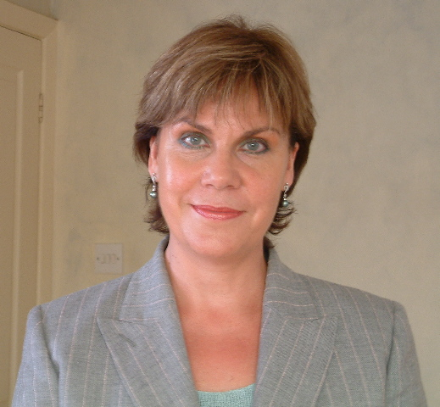
Sue Caden took up the leadership of Health Creation at School in September 2015 after a lifetime of teaching and management experience with adults and children as the Head of Early Years Education. She has many years of teaching experience working in both the independent and state sectors as well as being a teacher of health coaching, mentorship, consultancy and communication skills. She teaches and tutors on the Health Creation trainings and provides management support and quality control for the Health Creation at School Programme.

The Health Creation at School Programme
Now successfully implemented in over 30 Bristol schools, Health Creation at School is a dynamic health programme aimed at improving schools’ performance by enabling individuals and teams to reach their maximum potential for health, engagement and effectiveness. Based on the holistic approach to health and wellbeing HCAS provides a unique employee wellness programme for individual heads, teachers and entire schools. Through online assessment with the Picture of Health tool which looks at the interacting state of body, mind, team spirit and the school’s working environment, bespoke goals and action plans are created and implemented by in-house Health Creation Champions supported by our consultants. This results in measurable, sustainable benefits that include:
- Stress reduction by identification and management of the root cause of stress
- Increase in staff energy levels, health, wellbeing and motivation
- Decreased absenteeism and sickness costs
- Increased self-responsibility and improved self-care
- Improved time management and creativity
- Enhanced team building and active engagement by staff in improving the school’s positive health culture
- Mentorship support for vulnerable individuals needing support to re-build health and wellbeing
- Mentorship support for school leaders to build resilience and great role modelling of health and wellbeing

Teachers love this approach because it is about supporting them personally to become healthier and happier and also because they can have a say in choosing what measures are put in place to create a more positive and healthier working environment at school.

The Context for Health Creation at School

Results from the Education Staff Health Survey Report 2014, produced by the Teachers’ Support Network show that there are significant health issues challenging the teaching profession. In a survey of 2,463 teachers in school and further education:

- 88% reported suffering from stress, within which anxiety accounted for 72% and depression 45%
- 60% reported adverse affects on their performance
- 70% reported a loss of confidence at work
- 27% reported having to take time off work due to stress related problems
- 13% reported having left their jobs
And
- 89% said that workload pressures were a prime reason for stress-related issues affecting them
This very recent information suggests that the teaching profession is severely undermined by the unhealthy pressures to which it is subjected. Furthermore the report states that:

- 8% of respondents reported working in schools which had a health and wellbeing policy in place in their school reported a significant reduction in mental health issues affecting them
- Over 80% stated they believed that mental health issues would significantly decline if managers and staff worked together to reduce the workloads on everyone

Health Creation at School works with teachers and managers to deliver a systematic, workable and sustainable health and wellbeing programme. Using the tools and support provided, teachers and managers create a unique programme for their school which they positively support and maintain. In this way significant improvements can be expected.

Overview of the aims and methodology

The aims for the programme are to:
- Change the attitude of staff from a passive into a proactive relationship to their personal health and wellbeing, raising their vitality and improving performance and job satisfaction.
- Empower staff to define and implement the changes that they feel are necessary in their own school, creating maximum buy-in and commitment to the process.
- Teach staff the holistic model of health gets to the root causes of illness and unhappiness, highlighting the emotional, spiritual and environmental causes of dis-ease and showing where the right change will make the biggest impact
- Provide where needed individual health coaching support for those who are in leadership positions or who are struggling, helping to stop health problems and absenteeism before they start.
- Model a Health Creation environment and pass on vital lifelong learning to all who are part of the school community.
- Use the Picture of Health mapping tool to show staff and entire schools where they are strong and where they are vulnerable.
- Turn the outcome of the Picture of Health into a numeric score known as the Life Energy Factor. This applies for individuals and entire schools. Measure this over six months to assess the benefit of the school’s progamme and of the mentorship of individuals.

There are 8 steps in the HCaS programme:

- Initial meeting with the School Head to assess needs, issues and what has been tried before.
- Selection and training of 4 School Health Creation Champions
- Diagnostics with two versions of the online Picture of Health, one for individuals (Personal PoH) and a second for the entire school (Corporate PoH)
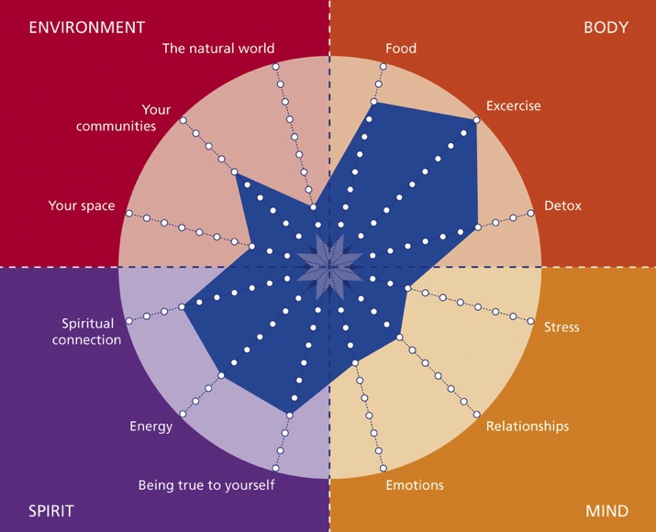
- Report production of:
- an anonymous Personal Report for each member of staff
- a collated Staff Report showing the strengths and weaknesses of the staff group as a whole
- the collated Corporate Report showing how staff feel about the current health culture within the school
- Inset Day to show staff their collated results and to create the first Health Creation Goals and Action Plan
- Consultant support over six months to achieve these and further health Creation Goals
- Final outcome measures with a repeat Picture of Health with repeat reports
- Presentation of the Health Creation Award for Health at Work and setting of the Annual Review Meeting

On the basis of the Picture of Health results:

- Heads and Staff may optionally go forward into a personal Health Creation Mentoring Programme, to receive health coaching support to analyse and succeed in making effective and sustainable healthy changes.
- Staff work together to form a School’s Health Creation Action Plan which they put into effect under the guidance and support of pre-trained in-house champions and the lead Health Creation Consultant.
- Talks, seminars, self-help classes and therapy session can be arranged to fit the needs of the school.
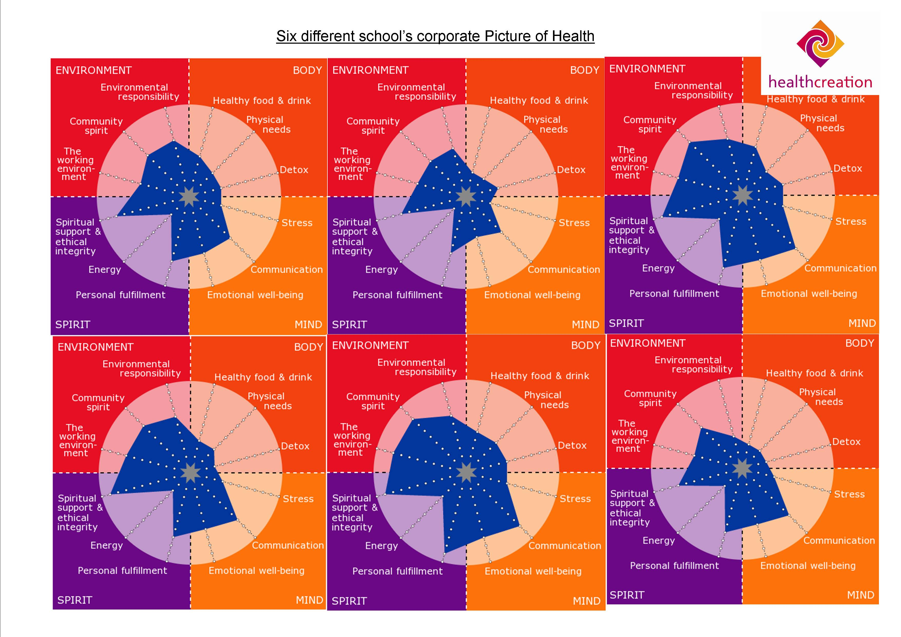
Corporate Picture of Health Results from 6 participating primary schools

The Picture of Health has 10 questions on 12 Health Creation Principles. (See Appendix 1) The ‘yes’ results are scored from the centre outwards meaning that the blue central area is where an individual or school is strong, with the gaps around this within the circle showing where improvements can be made. These six schools showed a very consistent pattern of need for improved diet, exercise, reduction in toxicity and for the raising of energy levels.
Results of One to One Health Creation Mentorship with Head Teachers and senior managers showed:

- Decrease in stress levels
- Decrease in anxiety and depression as measured by the HADS (Hospital Anxiety and Depression Scale)
- Increase in wellbeing as measured by the WHO 5-Item wellbeing scale of 20% – 40%
- Increase in Life Energy Factor as measured by the Picture of Health 0f 13% – 59% (See Appendix 2 for the personal results over 3-6 months mentorship for five head teachers)

Qualitative observations from HCAS participants:

“I was signed off work and put onto anti-depressants. The Health Creation Mentorship Programme gave me back control on my life.” (This Head teacher returned to work after six weeks)
“A lifeline”
“A very positive thing when working in a potentially stressful occupation - we often put ourselves last. Many people find prioritising their own wellbeing challenging so using something with a well-structured framework is such a good idea. The programme is holistic so has the benefit of being not only work centred.”

Conclusions and the Way Forward

The education sector has always been subject to change and challenge, and maintaining the work quality and wellbeing of staff is the central strand of rising to that challenge. The quality and wellbeing of education staff is a central concern for education policy makers as more schools fail and go into special measures because of stress and stress related illness. Further concern is arising due to the difficulty in succession planning of deputies to head teacher positions due to fears of erosion of health and wellbeing. Added to this is the current problem of wastage of junior teachers who are discouraged by the intense pressures and reducing job satisfaction facing teachers. Health Creation at School exists to give policy makers, managers and education professionals the tools they need to tackle the problem of stress, depression and anxiety in school and is confident as a result of pilot study in 30 Bristol schools that it can help to provide effective health and wellbeing services and standards deserved by the next generation.

Health Creation at School provides support for educators that is designed and delivered by medical led teaching professionals with coaching and consultancy skills. Teachers respond to our approach because we understand the world in which they work, and we help them to tailor their own programmes to the challenging, ever-changing and busy lifestyles which modern professionals are required to follow. We know that teachers have a responsibility to role model healthy self-care to pupils for a productive future life. Health Creation can help them to do this, and to work creatively with colleagues to make their task more manageable and more fulfilling.

In 2015, all our programmes will form part of an ongoing internal audit programme which will help build the picture on which formal research can be developed. From the data obtained we expect to contribute to a greater understanding of health and wellbeing in education and we plan to extend our reach regionally throughout the UK.

References
1. Teachers Support Network: Education Staff Health Survey Report 2014
http://teachersupport.info/research-policy/research-reports/education-staff-health-survey-2014

For further information or to arrange an introductory/exploratory meeting, please contact:

Sue Caden- Director-Health Creation at School - 07756 903759 - sue.caden@healthcreation.co.uk www.healthcreationatwork.com Office telephone – 01225-745737

Appendix 1 - The 12 Health Creation Principles for a Health Creation School

A Health Creation School:

a. TAKES CARE OF THE BODY of STAFF by:

- Promoting healthy eating and making healthy food and drink available for staff;
- Promoting physical fitness, relaxation and appropriate rest;
- Supporting staff to give up smoking, excess alcohol, recreational drugs, non-vital medication and to avoid other toxins.

b. TAKES CARE OF THE MIND and EMOTIONS of STAFF by:

- Promoting low stress and managing stress in school effectively;
- Promoting positive relationships and good communication between staff at all levels, involving them in management decisions and change processes;
- Promoting emotional well-being, listening to the feelings, hopes, fears and ideas of staff.

c. TAKES CARE OF THE SPIRIT of STAFF by:

- Helping them to become fulfilled, eliciting the personal goals and authentic aspirations of staff, helping them to develop to their maximum potential, recognising, rewarding and celebrating their achievements.
- Helping staff achieve high levels of energy, motivation and enthusiasm;
- Promoting the spiritual well-being of staff and having ethical integrity.

d. TAKES CARE OF THE LOCAL AND GLOBAL ENVIRONMENT by:

- Providing a good environments for staff to work and take breaks in;
- Establishing strong community links within the organisation and the local community;
- Being environmentally responsible to the local and global communities.

Appendix 2 – The Picture of Health results for five head teachers taken monthly for 3-6 months

Head Teacher 1

 | BODY |  |  | MIND |  |  | SPIRIT |  |  | ENVIRONMENT
M  O  N  T  H  S | F  O  O  D | E  X  E  R  C  I  S  E | D  E  T  O  X | S  T  R  E  S  S | R  E  L  A  tion  ships | E  M  O  T  I  O  N  S | T  R  U  E  T  O  S  E  L  F | V  I  T  A  L  I  T  Y | E  T  H  I  C  S | Y  O  U  R  S  P  A  C  E | C  O  M  M  U  N  I  T  y | N  A  T  U  R  E | LIFE  ENERGY  FACTOR ↑
1 | 10 | 1 | 10 | 0 | 2 | 3 | 3 | 0 | 5 | 3 | 4 | 7 | 40
2 | 7 | 6 | 10 | 4 | 3 | 5 | 5 | 5 | 8 | 8 | 7 | 7 | 62
3 | 10 | 6 | 10 | 9 | 6 | 9 | 9 | 9 | 10 | 9 | 8 | 8 | 86
4 | 10 | 8 | 10 | 10 | 9 | 10 | 9 | 9 | 10 | 10 | 9 | 10 | 95
5 | 10 | 10 | 10 | 10 | 10 | 10 | 10 | 10 | 10 | 10 | 9 | 10 | 99
6 | 10 | 10 | 10 | 10 | 10 | 10 | 10 | 10 | 10 | 10 | 9 | 10 | 99
% ↑per  Principle | 0 | 100 | 0 | 100 | 80 | 70 | 70 | 100 | 50 | 70 | 50 | 30 | TOTAL  ↑LEF  59%

Head Teacher 2

 | BODY |  |  | MIND |  |  | SPIRIT |  |  | ENVIRONMENT
M  O  N  T  H  S | F  O  O  D | E  X  E  R  C  I  S  E | D  E  T  O  X | S  T  R  E  S  S | R  E  L  A  tion  ships | E  M  O  T  I  O  N  S | T  R  U  E  T  O  S  E  L  F | V  I  T  A  L  I  T  Y | E  T  H  I  C  S | Y  O  U  R  S  P  A  C  E | C  O  M  M  U  N  I  T  y | N  A  T  U  R  E | LIFE  ENERGY  FACTOR ↑
1 | 7 | 4 | 6 | 1 | 3 | 1 | 0 | 2 | 0 | 3 | 3 | 6 | 30%
2 | 8 | 3 | 5 | 1 | 2 | 1 | 0 | 0 | 0 | 3 | 3 | 6 | 27%
3 | 9 | 4 | 7 | 2 | 5 | 3 | 4 | 4 | 6 | 8 | 3 | 8 | 53%
4 | 8 | 7 | 7 | 5 | 2 | 5 | 6 | 3 | 4 | 9 | 4 | 8 | 57%
5 | 9 | 6 | 8 | 5 | 9 | 10 | 7 | 7 | 8 | 7 | 6 | 8 | 75%
%↑per principle | 20 | 20 | 20 | 40 | 60 | 90 | 70 | 50 | 80 | 50 | 30 | 20 | TOTAL  ↑LEF  45%

Appendix 2 - Head Teacher PoH results continued

Head Teacher 3

 | BODY |  |  | MIND |  |  | SPIRIT |  |  | ENVIRONMENT
M  O  N  T  H  S | F  O  O  D | E  X  E  R  C  I  S  E | D  E  T  O  X | S  T  R  E  S  S | R  E  L  A  tion  ships | E  M  O  T  I  O  N  S | T  R  U  E  T  O  S  E  L  F | V  I  T  A  L  I  T  Y | E  T  H  I  C  S | Y  O  U  R  S  P  A  C  E | C  O  M  M  U  N  I  T  y | N  A  T  U  R  E | LIFE  ENERGY  FACTOR ↑
1 | 4 | 3 | 6 | 5 | 10 | 4 | 6 | 2 | 4 | 9 | 2 | 6 | 50
2 | 8 | 5 | 9 | 4 | 9 | 7 | 9 | 5 | 8 | 10 | 1 | 7 | 68
3 | 8 | 5 | 9 | 4 | 9 | 7 | 9 | 5 | 8 | 10 | 1 | 7 | 68
4 | 4 | 8 | 8 | 10 | 10 | 9 | 10 | 9 | 10 | 10 | 4 | 8 | 83
%↑per principle | 0 | 50 | 20 | 50 | 0 | 50 | 40 | 70 | 60 | 10 | 20 | 20 | TOTAL  ↑33%

Head Teacher 4
 | BODY |  |  | MIND |  |  | SPIRIT |  |  | ENVIRONMENT
M  O  N  T  H  S | F  O  O  D | E  X  E  R  C  I  S  E | D  E  T  O  X | S  T  R  E  S  S | R  E  L  A  tion  ships | E  M  O  T  I  O  N  S | T  R  U  E  T  O  S  E  L  F | V  I  T  A  L  I  T  Y | E  T  H  I  C  S | Y  O  U  R  S  P  A  C  E | C  O  M  M  U  N  I  T  y | N  A  T  U  R  E | LIFE  ENERGY  FACTOR ↑
1 | 9 | 1 | 9 | 5 | 9 | 7 | 7 | 2 | 3 | 10 | 7 | 8 | 64
2 | 8 | 2 | 9 | 8 | 9 | 6 | 8 | 3 | 5 | 10 | 7 | 9 | 70
3 | 9 | 2 | 9 | 6 | 9 | 8 | 9 | 3 | 4 | 10 | 7 | 8 | 70
%↑per principle |  | 10 | 0 | 10 | 0 | 10 | 20 | 10 | 10 | 0 | 0 | 0 | TOTAL ↑14%

Head Teacher 5

 | BODY |  |  | MIND |  |  | SPIRIT |  |  | ENVIRONMENT
M  O  N  T  H  S | F  O  O  D | E  X  E  R  C  I  S  E | D  E  T  O  X | S  T  R  E  S  S | R  E  L  A  tion  ships | E  M  O  T  I  O  N  S | T  R  U  E  T  O  S  E  L  F | V  I  T  A  L  I  T  Y | E  T  H  I  C  S | Y  O  U  R  S  P  A  C  E | C  O  M  M  U  N  I  T  y | N  A  T  U  R  E | LIFE  ENERGY  FACTOR ↑
1 | 9 | 2 | 9 | 6 | 10 | 7 | 6 | 3 | 10 | 4 | 8 | 8 | 70%
2 | 9 | 4 | 10 | 5 | 9 | 6 | 8 | 5 | 10 | 5 | 10 | 9 | 75%
3 | 9 | 6 | 10 | 9 | 9 | 8 | 7 | 4 | 10 | 7 | 10 | 9 | 82%
4 | 9 | 6 | 10 | 9 | 10 | 8 | 7 | 4 | 10 | 7 | 10 | 9 | 83%
% ↑ | 0 | 40 | 10 | 30 | 0 | 10 | 10 | 10 | 0 | 30 | 20 | 10 | TOTAL ↑13%

Sue Caden, David Jenkins and Dr Rosy Daniel – October 2015

